City of Cranston
Department of Community Development
155 Gansett Ave. - Pastore Youth Center
Cranston, RI 02910
401-780-3204/etommasiello@cranstonri.gov
401-943-3966 (Fax)

To: Public Service Applicants for Cranston CDBG Funds for 2026-2027

Re: Income Requirements for the Clientele of Public Service Organizations

The Cranston Department of Community Development is funded by the U.S. Department of Housing and Urban Development, in accordance with the Housing and Community Development Act of 1974. Community Development funds are available to those public service organizations that serve people having low to moderate incomes (adjusted for household size), or presumed eligible, and a U.S. Citizen. To qualify for CDBG funds, at least 51% of the clientele of public service organizations must be low to moderate income people, based on the current income guidelines determined by HUD. See attached income certification form. There are several ways to meet this requirement:

- Require information on household size and income so that it is evident that at least 51% of the clientele are people whose household income does not exceed the low- and moderate-income limit. Evidence may be substituted that establishes that the person assisted qualifies under another program which has income qualification criteria at least as restrictive as that used in the definitions of “low- and moderate-income person” and “low- and moderate-income household” such as JTPA and welfare programs.
- Have income eligibility requirements limiting your activity exclusively to low- and moderate-income people.
- Benefit a clientele who are generally presumed to be principally low- and moderate-income persons. Activities that exclusively serve a group of persons in any one or a combination of the following categories may be presumed to benefit persons, 51% of whom are low to moderate income: abused children, battered spouses, elderly persons, adults meeting the Bureau of Census’ Current Population Reports definition of “severely disabled”, homeless persons, illiterate adults, persons living with AIDS, and migrant farm workers.
- Describe how the nature and, if applicable, the location of the facility or service establishes that it is used predominantly by low- and moderate-income persons.

Persons (15 years old and older) are considered to be severely disabled if they:

- Use a wheelchair or another special aid for 6 months or longer.
- Are unable to perform one or more functional activities or need assistance with activities of daily living.
- Are prevented from working at a job or doing housework.
- Have a selected condition including autism, cerebral palsy, Alzheimer’s disease, senility, dementia, or mental retardation.
- Are less than 65 years of age and are covered by Medicare or receive Supplemental Security Income (SSI).

When preparing your application for CDBG funds for 2026-2027, please consider how your organization will satisfy the requirement that your organization’s clientele will be at least 51% low to moderate income people.

If you have any questions, please feel free to call the Cranston Department of Community Development at 401-780-6240.

______________________________ ____________________________
Signature of Applicant Date

Dear Applicant,

Attached to this letter is your CDBG Application for fiscal year 2026-2027. There are a few things that you should be aware of concerning your submission of the application to the CDBG office.

Deadline for Submission

- The deadline for submission is the end of the business day, 4:00 P.M on Friday, February 20th, 2026. Applications, and 10 copies, can be dropped off at 155 Gansett Ave. Pastore Youth Center, Cranston, RI 02910 or by mail.

Application Hearing Dates

- Applications for funding that pass an initial screening round by the Community Development office will then be reviewed by the CDBG Advisory Committee. The application reviews will be held at the Cranston Senior Center, 1070 Cranston Street, Cranston, RI 02920. As part of its review, the Committee will allow a ten (10) minute presentation to be made by each applicant organization. Reviews are currently scheduled to be heard on the evenings of:

Monday, March 2, 2026

Wednesday, March 4, 2026

You will be informed regarding the date and time of your presentation at a later date.

If you have any questions regarding the above, please contact the Cranston Office of Community Development at 401-780-6240.

Attached to the application are two copies of income requirements for public service organizations. Please sign one copy and submit it with your application to show that you have read and understand the requirements.

Ernie Tommasiello
Director
Department of Community Development

Cranston’s CDBG Proposal Evaluation Process
CDBG funding is distributed through a competitive application review process. Each submission is evaluated against the requirements and criteria outlined in the Request for Proposals (RFP) and the application materials. Community Development staff initially screen applications to confirm that all required threshold items have been submitted and that the application is complete. Each applicant will be invited to give a presentation to our Community Development Advisory Committee. Complete applications are then reviewed for substantive content and scored using the City’s CDBG standardized evaluation worksheet.
During the review process, Community Development may contact applicants to request additional information or clarification if questions arise. Following staff evaluation and scoring, the results are forwarded to Community Development’s Review Committee, which makes the final funding determinations.
Although strong proposal writing does not ensure an award, the competition for CDBG funds is rigorous. Proposals that are thorough, clearly written, and fully responsive to the RFP evaluation criteria are most likely to be successful.
Applicants with questions regarding the application or review process may contact the City of Cranston’s Department of Community Development at (401) 780-3204.
Aside from the review of your application, we will also use a Risk-Based monitoring and Scoring Matrix. The matrix will evaluate:
- Program Performance
- National Objective Compliance
- Financial Management
- Reporting & Recordkeeping
- Prior Monitoring History
- Organizational Capacity
Points will be allocated based upon Risk level for each category above, with 1 point for Low Risk, 2 points for Moderate Risk, and 3 points for High Risk. Each applicant will score between 6 and 18 points with the lowest scores awarded to the applicants that best display the requirements and criteria outlined in the Request for Proposals.
Please contact Community Development if you have any questions at (401)780-3204

Your original application and 10 copies must be submitted together.

C.D. #_______________
(Office use only)

Cranston Department of Community Development
Application for Funds
Fiscal Year July 1, 2026, to June 30, 2027

INSTRUCTIONS: This application requests the minimum amount of information necessary for proposal review. Additional information should be included as necessary. The Community Development Department may request additional information from the sponsor applicant. For more information on the Block Grant program, or assistance, please contact the Department of Community Development, 155 Gansett Ave., Cranston, RI 02910, telephone 401-780-3204.

- Agency or Individual applying _________________________________________

Address__________________________________________________________

Contact___________________________________________________________

Telephone__________________ E-Mail _____________________________

- Why are you seeking a Community Development grant? What needs of the community will be addressed? In answer, please state the objective and the outcome to be achieved.
Please check one: ____ Limited clientele presumed eligible
____ Limited clientele income verification

- How will this program meet those needs? Be concise and specific.
___________________________________________________________________________________________________________________________________________________________________________________________________

4. How many people from Cranston do you expect your program to serve for the first time during the fiscal year 2026-2027?

5. For a program to qualify for CDBG funds, at least 51% of the people served by the program must be of low and moderate income. Please describe the process you will use to identify these persons and ensure the program meets this requirement. (Please refer to Attachment A.) Please include a copy of your intake form. Blank)

________________________________________________________________________

6. What part of Cranston’s population constitutes the principal constituency of your
program?

7. Will this program benefit a specific geographic area? If so, please describe it in detail and, if possible, attach a map of the area.

8. Describe your administrative structure and indicate whether these funds will
be used to pay Salaries or other Administrative Expenses.

9. HUD has a strong interest in meeting the needs of minorities. Will your program
target any specific minority group? If so, please explain how this program will serve the needs of minorities.

10. Please list all other sources of funding for your organization as follows:

Name of other source: ________________________________
Address: ________________________________
________________________________

Telephone number: ( ) ____________

Amount received from other source: $ _____________________

Name of other source: ________________________________
Address: ________________________________
________________________________

Telephone number: ( ) ____________

Amount received from other source: $ _____________________

Name of other source: ________________________________
Address: ________________________________
________________________________

Telephone number: ( ) _____________________

Amount received from other source: $ _____________________

11. Estimated Program Budget and breakdown of line items for application
budget year (2024/2025):

Covered by Covered by Totals
CDBG Funding Other Funds

Salaries: $ ____________ $ ____________ $ ____________

Rent: $ ____________ $ ____________ $ ____________

Equipment
(rentals, if
applicable) $ ____________ $ ____________ $ ____________

Other $ ____________ $ ____________ $ ____________

12. If CDBG funds are to cover salaries and benefits, please list all proposed staff positions funded with CDBG funds that relate to the proposed activity. Please include a job description for each person.

Budget Item | Calculation | CDBG Request

PERSONNEL
Salaried Positions – Job Titles | Provide rate of pay (hourly/salary) and percentage of time spent on project (Full-Time Equivalent) or hours per week

Salaries Total
Fringe Benefits
PERSONNEL TOTAL | Total of Personnel & Fringe Benefits

Program History

Are you currently receiving CDBG Funds?

Yes ______ No _______ If yes, amount of funding ______________

Total CDBG Funds requested this year ______________________

Does your agency have any of the following? (Respond yes or no)
If the answer is yes, please provide a copy.

Articles of Incorporation _________________
Active 501(C)3 from IRS _________________
By-laws _________________
Non-Discrimination Policy _________________
Employee bonding _________________
Liability Insurance _________________
Theft Insurance _________________
Fire Insurance _________________
Board of Directors _________________
Financial Audits _________________
(If so, please provide 1 copy)
UEI Number __________________
Conflict of Interest disclosure ________________
Mission Statement __________________

Signature: ______________________________
Address: ______________________________
City and State: _____________________________
Telephone: _______________________________

NOTE: All programs must be under contract within the fiscal year funds are awarded. Any funds not under contract will be recaptured by this office on June 15, 2027.

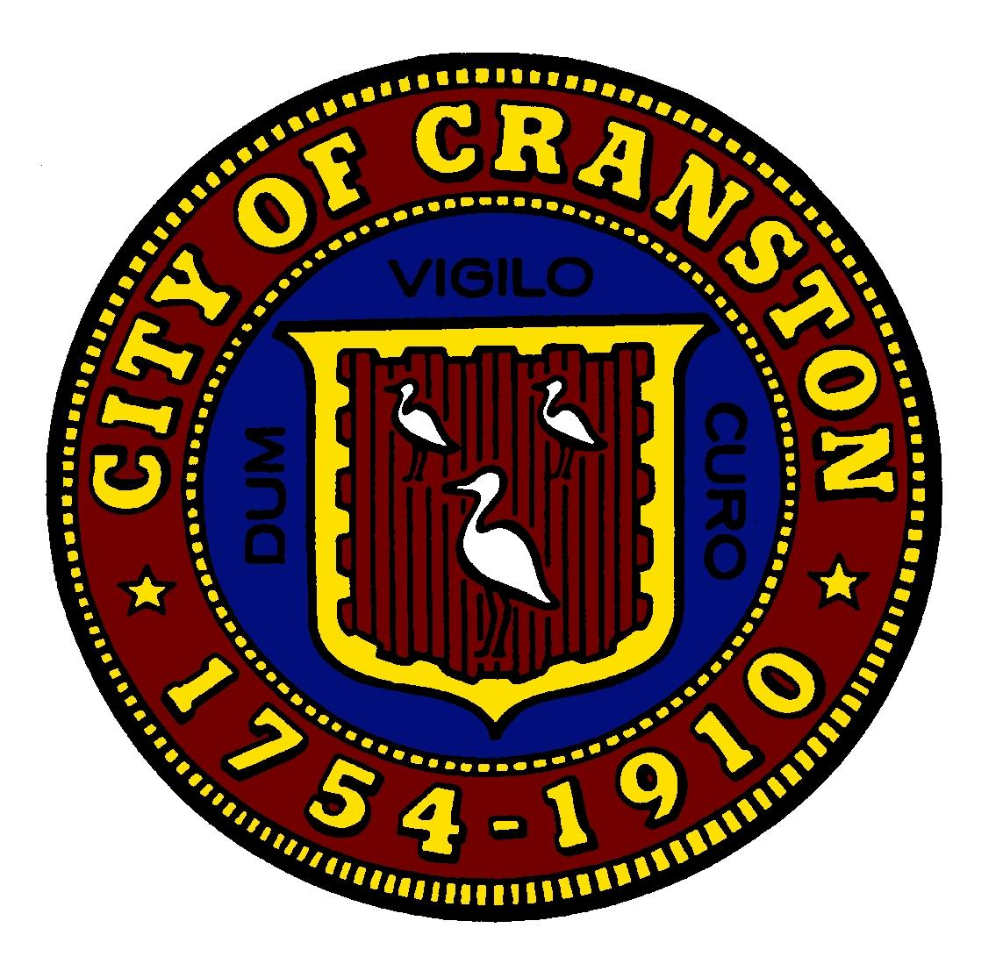
City of Cranston
Department of Community Development
155 Gansett Ave.
Cranston, RI 02910

Conflict of Interest Disclosure Form – CDBG Subrecipient

Project / Application Name: __________________________________________________

Applicant / Organization: ____________________________________________________

Address: _______________________________________________________________________

Contact Person / Title: _______________________________________________________

Phone / Email: __________________________________________

Date: ________________________

Instructions:
Federal regulations prohibit conflicts of interest for persons who exercise functions or responsibilities with respect to CDBG-assisted activities and who may benefit from those activities, either directly or indirectly. Please answer all questions below and attach additional pages if necessary.
1. Relationship to CDBG Program
Are you currently or have you ever been an employee, agent, consultant, officer, or elected or appointed official of the Grantee, municipality, or any organization receiving CDBG funds?
☐ Yes ☐ No

If yes, please explain:
______________________________________________________________________
______________________________________________________________________

2. Financial or Business Interests
Do you or any immediate family member (spouse, parent, child, sibling, in-laws, or business partner) have a financial or business interest that may benefit from this CDBG-funded activity?
☐ Yes ☐ No

If yes, please describe:
______________________________________________________________________
______________________________________________________________________

3. Other Potential Conflicts
Please disclose any other relationships or circumstances that could be perceived as a conflict of interest:
______________________________________________________________________
______________________________________________________________________

4. Certification
I certify that the information provided above is true and complete to the best of my knowledge. I agree to notify the Grantee immediately of any changes.

Signature: __________________________________________________________

Printed Name: _____________________________________________________

Title: _______________________________________________________________

Date: ___________________________________

Attachment A – For Applicant’s Records

To: Public Service Applicants for Cranston CDBG Funds for 2026-2027

Re: Income Requirements for the Clientele of Public Service Organizations

The Cranston Department of Community Development is funded by the U.S. Department of Housing and Urban Development, in accordance with the Housing and Community Development Act of 1974 Community Development funds are available to those public service organizations that serve people having low to moderate incomes (adjusted for household size), or presumed eligible, and a U.S. Citizen. To qualify for CDBG funds, at least 51% of the clientele of public service organizations must be low to moderate income people, based on the current income guidelines determined by HUD. See attached income certification form. There are several ways to meet this requirement:

1) Require information on household size and income so that it is evident that at least 51% of the clientele are persons whose household income does not exceed the low- and moderate-income limit. Evidence may be substituted that establishes that the person assisted qualifies under another program which has income qualification criteria at least as restrictive as that used in the definitions of “low- and moderate-income person” and “low- and moderate-income household” such as JTPA and welfare programs.
2) Have income eligibility requirements limiting your activity exclusively to low and moderate income persons;
3) Benefit a clientele who are generally presumed to be principally low- and moderate-income persons. Activities that exclusively serve a group of persons in any one or a combination of the following categories may be presumed to benefit persons, 51% of whom are low to moderate income: abused children, battered spouses, elderly persons, adults meeting the Bureau of Census’ Current Population Reports definition of “severely disabled”, homeless persons, illiterate adults, persons living with AIDS, and migrant farm workers.
4) Describe how the nature and, if applicable, the location of the facility or service establishes that it is used predominantly by low- and moderate-income persons.

Persons (15 years old and older) are considered to be severely disabled if they:

- Use a wheelchair or another special aid for 6 months or longer.
- Are unable to perform one or more functional activities, or need assistance with activities of daily living.
- Are prevented from working at a job or doing housework.
- Have a selected condition including autism, cerebral palsy, Alzheimer’s disease, senility, dementia, or mental retardation.
- Are less than 65 years of age and are covered by Medicare or receive Supplemental Security Income (SSI).

When preparing your application for CDBG funds for 2026-2027, please consider how your organization will satisfy the requirement that your organization’s clientele will be at least 51% low to moderate income people.

If you have any questions, please feel free to call the Cranston Department of Community Development at 401-780-6240.

